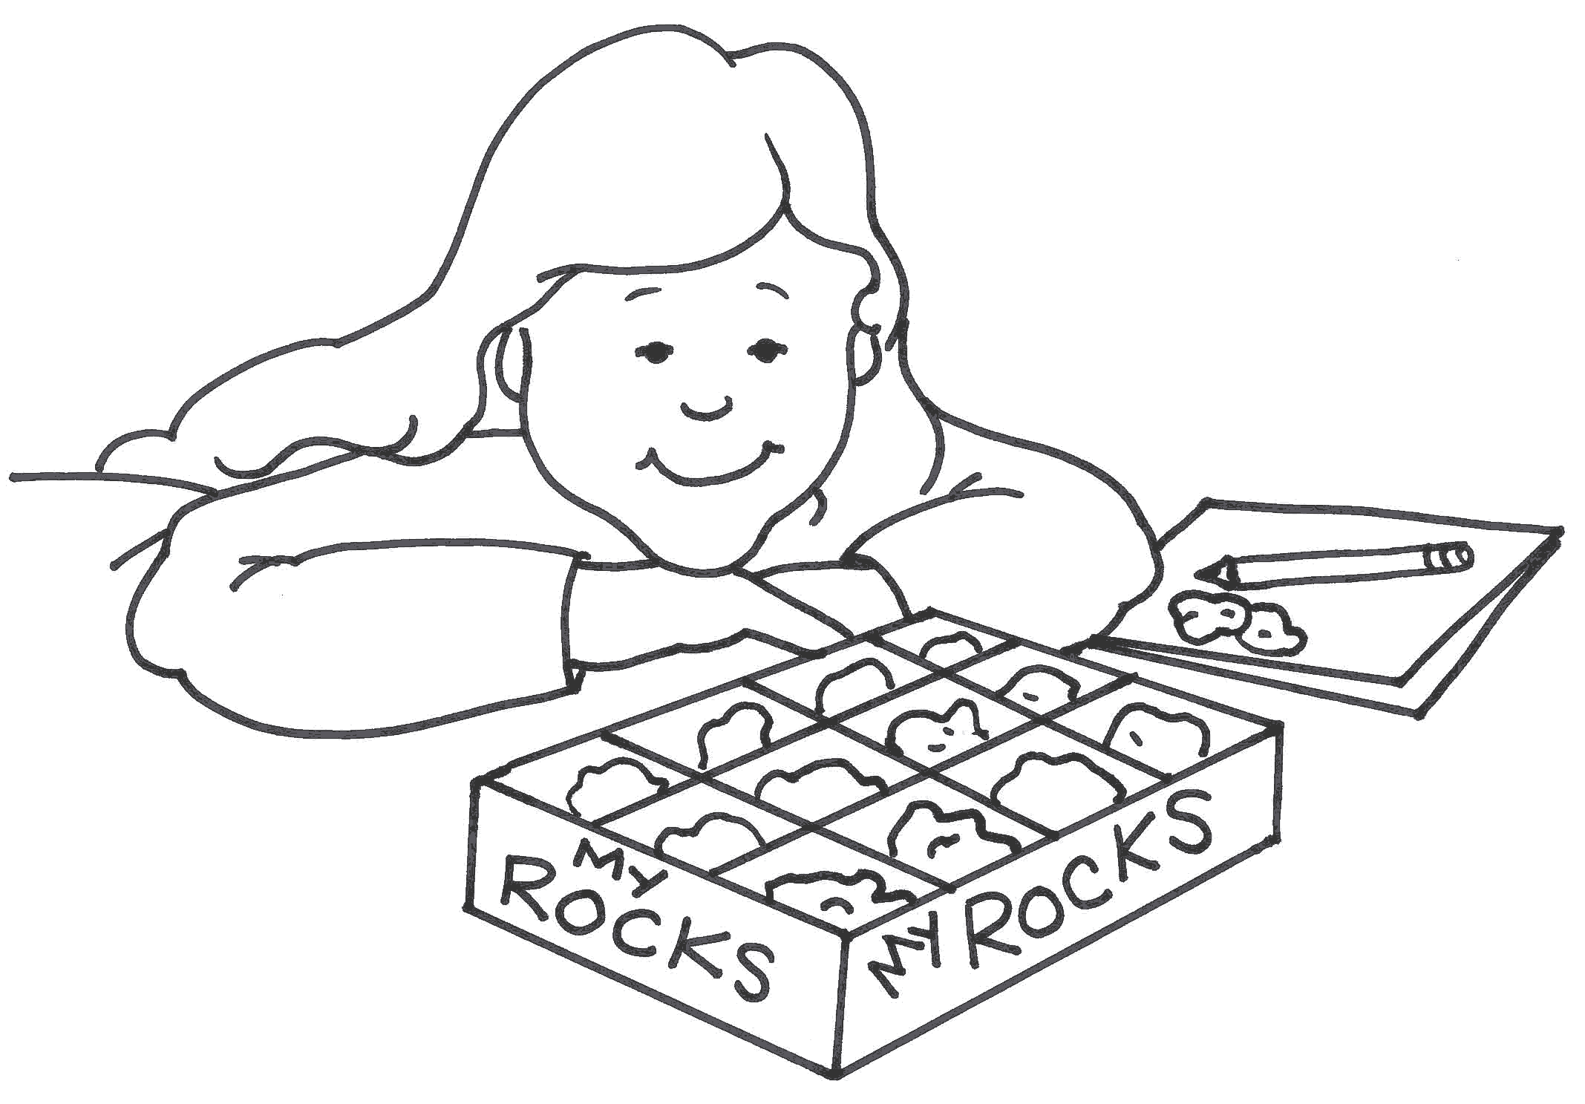
Pearson Science SB 7.

Write in your own words what you think the meaning of the words in italics might be. When you have had a go use the textbook, p.68 and 75, to get the meanings.

Words | Possible meaning | Textbook meaning
Resource
Renewable
Non-Renewable
Photosynthesis
Igneous Rock
Metamorphic Rock
Weathering
Sediments
Erosion
Deposition

